Information for New Member regarding online resources

My Rotary
This online resource for members is an excellent source of information on Rotary and its programmes, as well as club goals.
It also contains a Learning Centre with online courses about various aspects of Rotary and being a member.
Included in this document are instructions on “How to Create a My Rotary account”.
Note: you have to register initially with the email address you gave to your club. You can always change your log-in email later if you wish.
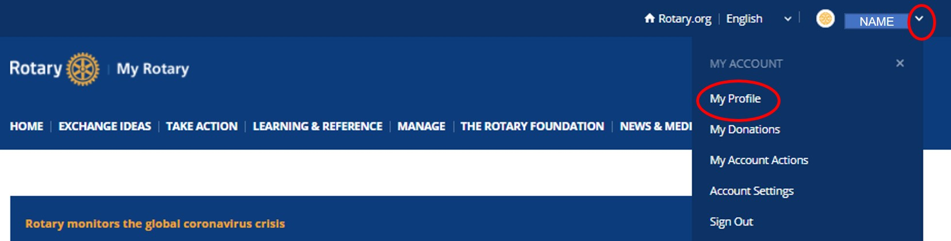
Once you have created your My Rotary account and logged in, click on the down arrow beside your name and go to ‘My Profile’ to confirm and/or update your contact details.

If you have participated previously in a Rotary-sponsored programme, such as Youth Exchange, Rotary Youth Leadership Award or Group Study Exchange (to name a few) you can add it in the ‘My Profile’ area under 'Programs', which will ensure you are recorded in the Rotary Alumni database.
We recommend you explore the rest of the My Rotary site in your own time. It has a lot of data and graphics, so you may find it slower than a corporate or university server setup.
District 9910 website
Your Rotary club is located within Rotary District 9910, which has a website at rotarydistrict9910.org
The area For Rotarians has more information about aspects of the district’s operation.
The area under Our Programs contains information about our Youth programs and others.
Further down the Home page you will find different information about Rotary District 9910, such as:
District leaders; Other Rotary clubs in the district; District events calendar; Link to the District Newsletters and more
District 9910 is one of six districts covering New Zealand and the Pacific Islands, also known as Rotary Oceania. The Rotary Oceania website can be found at rotaryoceania.zone.

Facebook
There are several Rotary organisations and programmes with a Facebook presence. Start with the following:
- ‘Like’ the District 9910 Facebook Page @RotaryDistrict9910
- ‘Join’ the Rotary District 9910 Rotarians Group www.facebook.com/groups/RotaryDistrict9910
- ‘Like’ the Rotary Oceania Facebook Page @rotaryoceania

[Add your club’s website and/or social media sites and required action to take]

